|  |  |  |  |
| --- | --- | --- | --- |
| 1 | | 176,712.0 | |
| NUMERO DE FRONTERAS | | ENERGIA AGREGADA | |
|  | | | |
|  | |  | |
| CONTRATO | | VENCIMIENTO CONTRATO | |
|  | | | |
| 459,404,960 | 119 | | 19,932,676 |
| INGRESO 2021 | DÍAS CERTIFICADOS 2021 | | ENERGIA RESPALDADA 2021 |

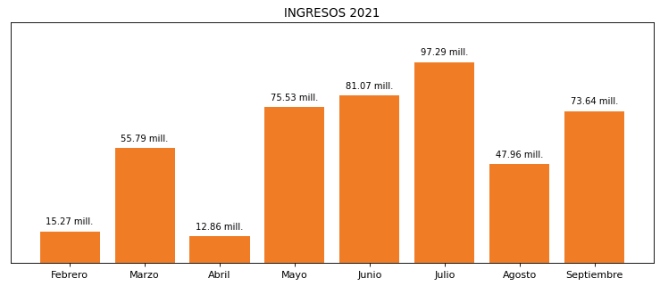

|  |
| --- |
| **PRAXAIR TOCANCIPA**  USUARIO |

|  |
| --- |
| **Mateo Porras**  Ejecutivo de cuenta |

|  |
| --- |
| Primera fecha: PUNTO FOCAL |

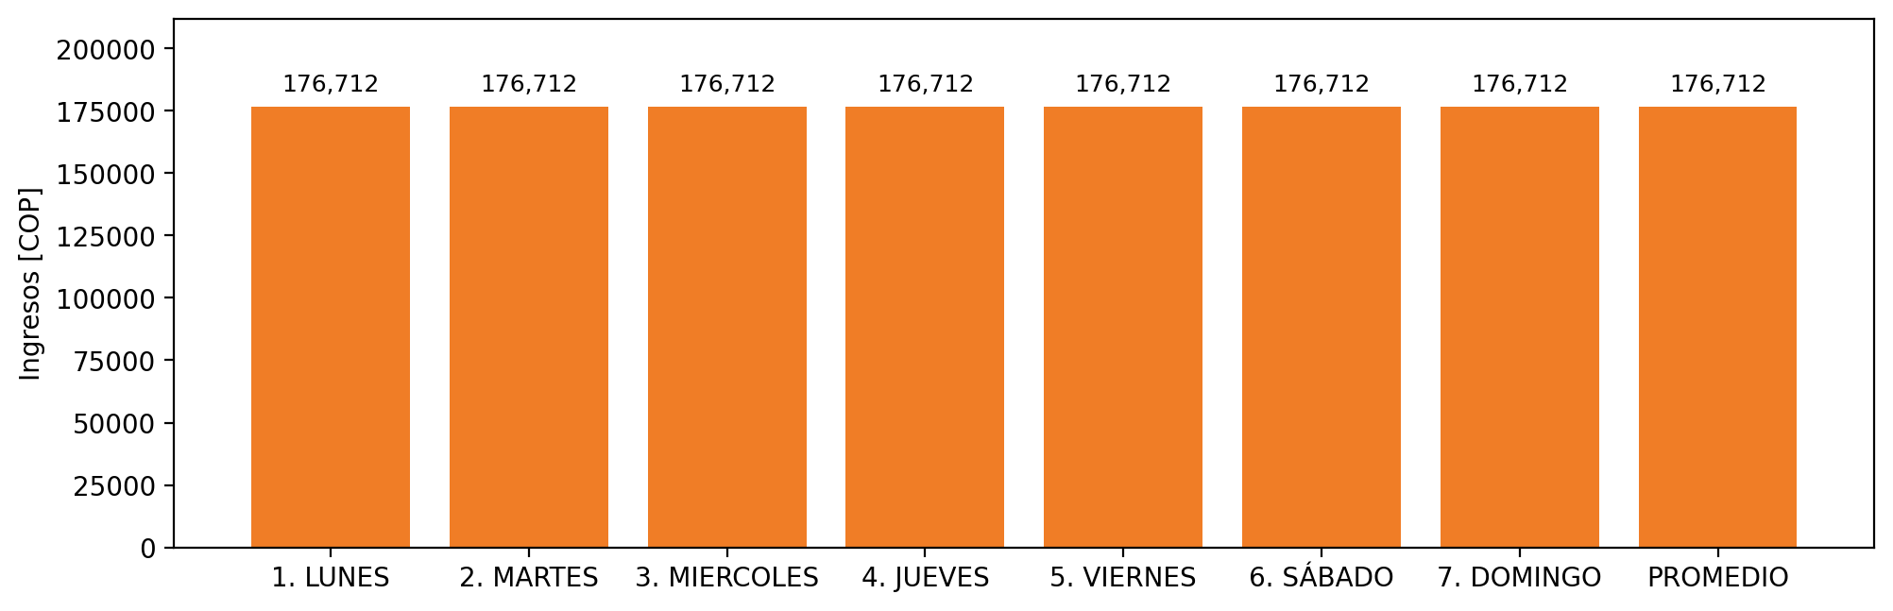

|  |  |  |  |  |  |  |  |  |  |
| --- | --- | --- | --- | --- | --- | --- | --- | --- | --- |
| **FRONTERA COMERCIAL** | **TIPO DDV** | **COD SIC** | **PREDIO** | **PROMEDIO** | **MARGEN** | **ÚLTIMA DESCONEXION** | **DÍAS CERTIFICADOS** | **ACTUALIZACION** | **PROXIMA PRUEBA DDV** |
| PRAXAIR TOCANCIPA | Frt30837 | Frt14138 | Prd00944 | 176,712 | 0,42 | 2021-08-22 | 18.0 | 2021-12-02 | 2022-01-14 |